QUESTIONAIRRE: Cornell Evolution Project

SECTION ONE: Statement of Belief

1) Do you consider yourself a religious person?

* YES
* NO

2) Which best describes your religion?

* Christian
* Islamic
* Judaism
* Buddhism
* Other

3) Which best describes your belief system?

* Atheist
* Agnostic
* Naturalist
* Other

4) Do you believe in God, or an entity that exists beyond the scope of our observations that is responsible for designing and maintaining life on earth?

* I believe in God as described in this question.
* I believe in God, but my God merely started the processes of the universe, and of life on earth, and does not intervene on a day-to-day basis.
* I don't believe in God in any traditional sense of the word.
* I don't believe in God, but I do believe that there are entities in the universe that are beyond the scope of science and are forever going to remain so.

5) What role does evidence play for you in determining your belief in God?

* I believe that there is a God no matter how insubstantial the evidence.
* I believe that there is not enough evidence to justify a belief in God.
* I don't apply scientific methodology or principles to my beliefs.

6) I believe that there is something, not known to science, in human beings that lives on after the body dies.

* Agree with this statement
* Disagree with this statement

7) Please choose only one of the following:

* All biological organisms are locally determined by heredity and environment but humans still possess free will.
* All biological organisms are locally determined by heredity and environment and humans have no free will.

SECTION TWO: What Evolution Studies, What It Ignores

8) Organisms, including humans, consist of the following:

* Material properties¹
* Spiritual/Non-material properties
* BOTH material and spiritual/non-material properties

¹Properties are here defined as determining factors.

9) I believe that the findings of evolutionary biology can influence and alter morality.

* Agree with this statement
* Disagree with this statement

10) Do you believe that evolution teaches us something about the objective reality of life on earth or is such a topic better left for philosophers to debate?

* I am committed to teaching about the objective reality of life on earth.
* I am content to let philosophers debate about objective reality, without addressing it in my teaching.
* I don't believe that there is such a thing as objective reality, we all create our own reality.

11) What is your view of purpose and progress in evolution?

* Neither purpose nor progress plays any ultimate² role in evolution.
* Evolution exhibits no ultimate purpose, but progress does occur in evolution.
* Ultimate purpose plays a role in evolution and progress is a part of that purpose.
* Ultimate purpose plays a role in evolution, but it doesn't entail progress.

²"Ultimate" refers to any of the following concepts: intelligent design, teleology, or determining factors that science does not study.

12) What is your opinion on the relationship between evolution and religion?

* They are non-overlapping magisteria* whose tenets are not in conflict.
* Religion is a social phenomenon that has developed with the biological evolution of Homo sapiens. Therefore religion should be considered as a part of our biological heritage and its tenets should be seen as a labile social adaptation, subject to change and reinterpretation.
* They are mutually exclusive magisteria whose tenets indicate mutually exclusive conclusions.
* They are totally harmonious. Evolution is one of many ways to elucidate the evidences of God's designs.

SECTION THREE: Religious Belief and Practice of Evolution

13) I keep my beliefs about morality and ethics separate from my practice and teaching of evolution.

* Agree with this statement
* Disagree with this statement

Look at the following diagram. Choose the letter that corresponds to your philosophical preference. For instance, if you are a naturalist* choose "A" if you are a Deist*, choose "I" and so on. If your philosophical position is intermediate between the end points, there are lettered fields you can choose. For instance "C" corresponds to a philosophy that is predominantly naturalist but includes some leanings toward deism. "H" is a deistic philosophy with some leanings toward theism*. "J", "K", and "L" are neutral positions along their respective axes. "M" is a totally neutral position, a philosophy without any leanings toward naturalism, deism, or theism.
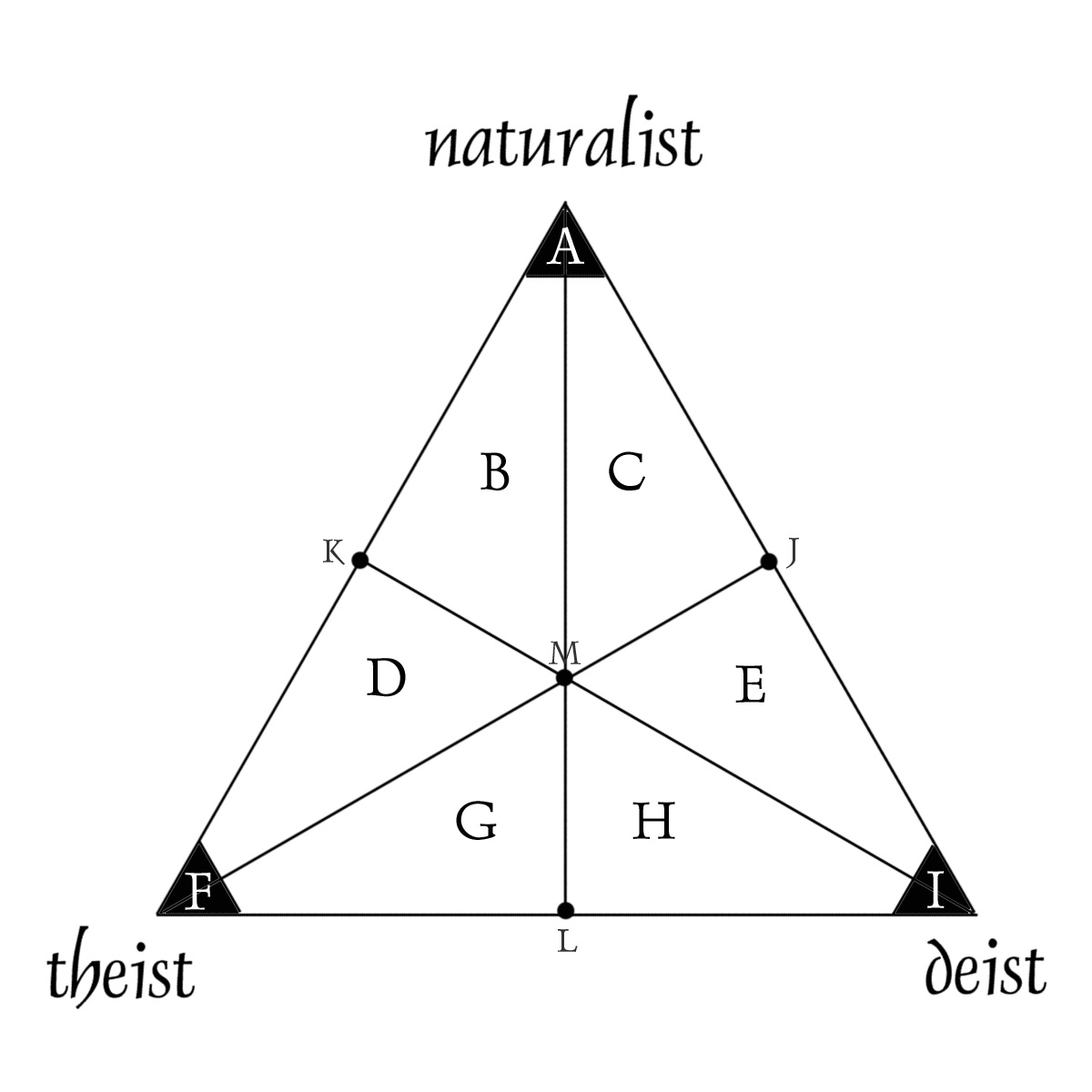

14) Click on the letter of your choice:

* A
* B
* C
* D
* E
* F
* G
* H
* I
* J
* K
* L
* M

*Naturalism, the philosophical position that matter, energy, and natural laws make up the total composition of the universe, and that no God created or designed it, truth is found through the empirical procedure of exploration and verification.

*Deism, the philosophical position that God exists and created the universe and its forces and matter but does not intervene in daily events; he is an uncaring God who started the evolutionary process but plays no role in its outcome; truth is revealed by design.

*Theism, the philosophical position that God exists and cares for humans, and intervenes in daily events and processes to affect outcomes for the good of mankind, and that truth is revealed by such goodness.

15) Do you think that your body of work in evolutionary biology reflects your position on the diagram of #14?

* Yes
* No

16) Do you consider yourself a naturalist in the metaphysical sense?*

* YES
* NO

* One who subscribes to metaphysical naturalism, the notion that the only reliable method of discovering truth comes from empirical investigation.

SECTION THREE: Religious Belief and Practice of Evolution

17) What kind of belief system would you advocate, if pressed, as being the most consonant with a lifelong practice of evolution?

* One of the traditional religions (i.e. Christianity, Islam, Judaism, Buddhism etc.)
* A naturalistic one that is based on materialism, and incorporates advances in scientific knowledge
* One that incorporates some aspects of traditional religion and some aspects of modern science
* Other

18) Were you formally introduced to any religion in a ceremony or rite of passage?

* Yes
* No
*N/A

Are you practicing in that religion now?

* Yes
* No
* N/A

For those who answered NO: Did the study and teaching of Evolution have an ideological impact on your decision to discontinue practicing that religion?

* Yes
* No
* N/A

Are you practicing in any religion now?

* Yes
* No
* N/A

