Bennington College Field Course in Coral Reef Science

Faculty: Betsy Sherman and Janet Foley

2 credits
Jan. 4-11, 2014

Coral reefs are among the most diverse, unique and beautiful of ecosystems on the planet. Alas, they are also quite vulnerable to various environmental assaults and most of the reefs on earth are in real jeopardy. In order to gain a more robust understanding of reefs, we will study reefs on site in the Caribbean. Students will learn the taxonomy, identification and characteristics of the animals that live in coral reefs. The course will take place on the island of Grand Cayman. Students will have an opportunity to become certified scuba divers and participate in ongoing research. Students will collect and analyze fish inventory data and submit those data to the environmental organization, REEF (Reef Environmental Education Foundation). Students will be able to compare their data with prior research. We will also discuss reef ecology with Tim Austin a research scientist with the Cayman Islands Department of the Environment. We will also participate in a beach clean-up activity.

The questions we will consider include:

-how can we quantify the biodiversity in reef ecosystems
-what environmental factors affect reef organization

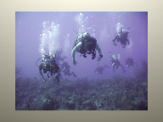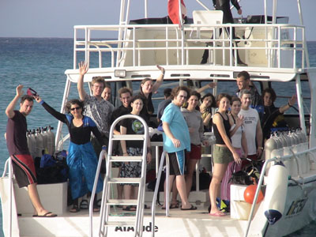

Students will prepare for this class beforehand by learning fish taxonomy using the paperback included in the Reef Starter Kit ($20) and online resources such as www.reef.org. Betsy will present a seminar on reef biodiversity before the end of term that participants must attend.

An advanced coral reef class is possible for those students who participated in the previous course.

Why Grand Cayman?

The faculty are very familiar with Grand Cayman and have been diving there for many years. The island has many advantages. First, it is extremely safe: there is an excellent hospital, potable water, easy access to and from the U.S. and there is a Recompression Chamber run by naval trained professionals associated with the hospital. The reefs that surround Grand Cayman are part of a protected Marine Preserve and all of the dive operations are committed to maintaining the vitality of this extraordinary habitat. We will work with an excellent dive operation, Divetech. The owner, Nancy Easterbrook is well known in the dive community as a superb technical diver and teacher. We are also fortunate to be housed and fed in Cobalt Coast, run by Arie Barendrecht, who is committed to “protecting and enhancing the environment,” in and around Grand Cayman.

Cost:

1) Tuition plus dive package: $2650

We must have an enrollment of at least 10 but no more than 16 in order for the course to take place.

The package includes:

2 Bennington College credits
7 nights accommodations
Breakfast, lunch, dinner all days
Airport transfers
Welcome cocktail on arrival
Night dive including lights
Equipment rental for the week including BCD, Regulator, Dive Computer, Wetsuit, Tanks, Weights
Unlimited shore diving from Cobalt Coast
Open Water Certification Students: Completion of Open water certification including 4 days of 2-tank boat trips, wreck dive, night dive
Certified Divers: 6 days of 2-tank boat trips, wreck dive, night dive

2) Round trip airfare: from $450 (estimate only; depends what airport you fly from; it is your responsibility to get to and from the airport on Grand Cayman-airport code is GCM--we’ll get you to and from the airport)

3) Mask, fins, and snorkel: $150 (estimate; while you can rent this stuff from the dive shop, it is better to have our own; I can help you buy them in the states).

4) Reef Starter Kit: $20

5) PADI elearning open water course: $138 https://www.padi.com/elearning-scuba-registration/purchasecourse.aspx

Do next:

In order to confirm all of the arrangements that need to be made in advance, I will need to have a commitment from you soon. I will consider all students for this course but it is essential that the students who participate work well in a group so I will be making a judgment in consultation with the Dean’s office. Permission of instructor is required.

If you are accepted into the course, we need a deposit of $1000 by Oct. 22. The full deposit will only be returned if the course is canceled. See Intent to Enroll document.

Documents to bring to Caymans
-health insurance card (including important phone # if pre-approval is necessary for treatment)
-DAN dive insurance card (desirable but not required)
-valid passport
-return airline ticket
-name and phone number of emergency contact (give to Betsy)
-PADI health form-signed by a physician if necessary

CHECK YOUR COLLEGE EMAIL FOR UPDATES

